Falls Creek Race Club (FCRC)

Website Project

March 2015

Author: Fraser Wilkinson

Contents

Overview 1

Front Page 2

Content 3

Membership 3

Payments 3

Membership Lists 4

Information Pack 4

Technical Details 5

Domain 5

Hosting 5

Content Management System (CMS) 6

Summary 6

## Overview

The current website has been in place for some time (since 2011?). It is maintained by FCRM and updates are slow to go live. Whilst it has been useful over the years, the current design makes it difficult to find information quickly and difficult to get information loaded.

This project aims to make improvements in the following areas:

* Easy access to information for each program
  + No need to see all information for all programs
* Simpler navigation
* Comprehensive sitemap
* Responsive design (viewable on mobile devices)
* Downloadable Information handbooks
* Adding YouTube, Volunteering & Fundraising sections
* Social media interaction
  + Facebook feed
  + Instagram feed
* On-line Membership signup
* Integration with MailChimp for email newsletters
* Easy to add/edit content for registered users

## Front Page

This is crucial for improving usability of the FCRC website. It has links to the six program boxes:

1. School Holidays
2. Weekend Warriors
3. Freeskiing (?)
4. Entry Level (5-12yrs)
5. U14 & U16
6. FIS

(Note: these items are to be confirmed by el President)

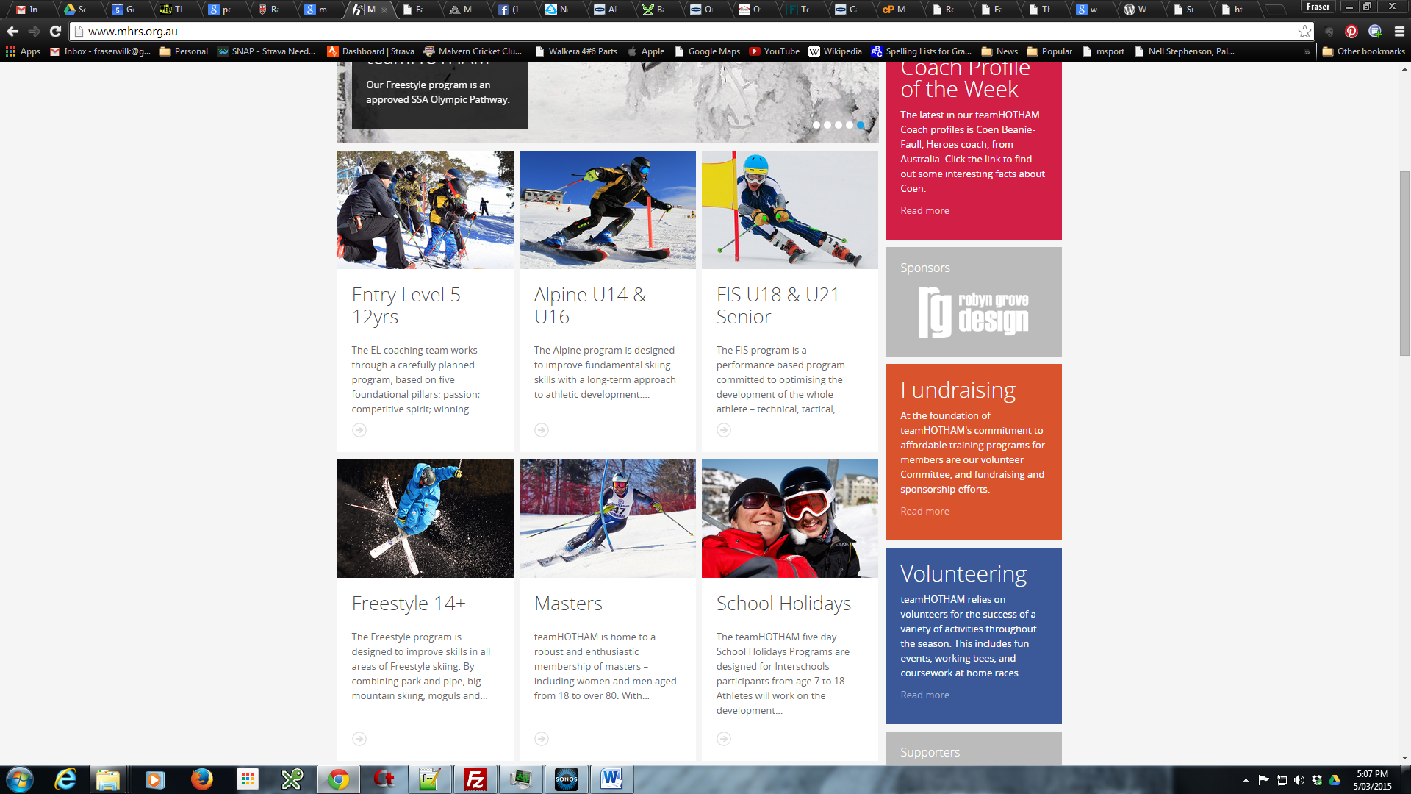

Mt Hotham RC front page - example

There are also other features on the front page:

* Interactive menu
* Facebook, YouTube & Instagram links
* Training & Events Calendar
* Sponsors (incl links)
* Current News Items

## Content

Existing content may be sufficient for the transition to any new platform. Whilst there will be some updates along the way, these will be managed in an ad-hoc manner and will help the content managers (any volunteers?) become familiar with the proposed Content Management System (CMS).

## Membership

The current membership system requires manual reconciliation against payments made. The current membership list requires manual processes to update.

### Payments

Both of these issues are resolved when using an online payment system. Streamlining the membership process using a system like TryBooking is easy for members and gives the club an electronic membership list.

A brief review of other race clubs:

* Mt Hotham Race Club use TryBooking (<http://www.trybooking.com/>).   
  Cost: 2.1% + 50c per transaction
* Team Buller Riders (TBR) use an off-line system similar to current FCRC practice
* Team Mt Buller use an on-line form then email invoice with a link for payment
* Thredbo Ski Racing Club doesn’t offer membership through their website. It appears you must register interest via email and they contact you.
* Perisher Winter Sports Club payments are made through the Perisher eStore using their cart. Easy but they are reliant on the Perisher RM to handle membership.

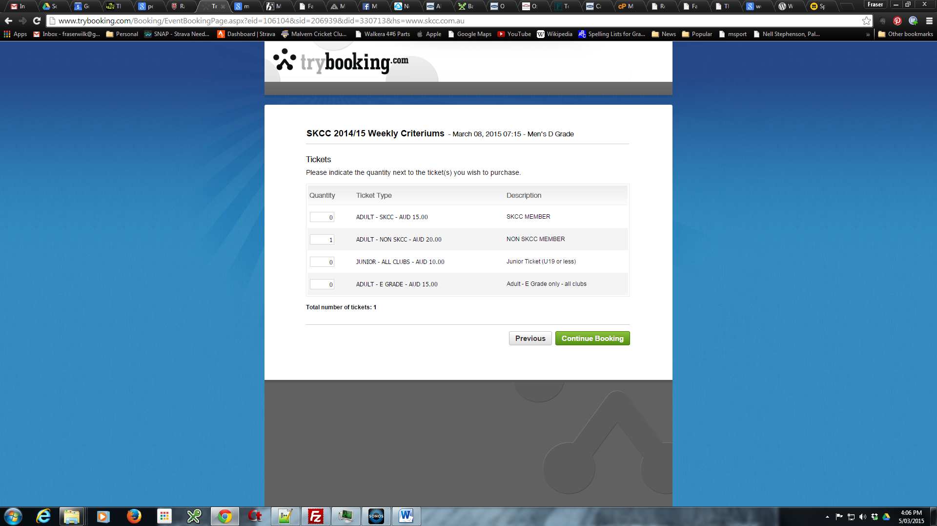

Example TryBooking page

### Membership Lists

Great benefits can be made by ensuring members enter their details online. The benefits include:

* Member’s details are up to date
* Marketing & information updates are easy
* Full knowledge of membership numbers
* Full knowledge of Program numbers
* Next year is easier for previous members as their information is retained

## Information Pack

New members to the club need to know plenty of information. Historically we’ve relied on the Race Club Handbook (2010!). This needs to be updated for 2015.

There is also a Parents Handbook, which is a cut-down version of the Race Club Handbook. This doubles up information and can lead to erroneous or incorrect information becoming available. The information needs to be specific for each handbook.

Additionally, we can provide the most important facts via pages on the website.

Updating of the Race Club Handbook is ***outside the scope of this project*** but should be done concurrently to ensure correct information is available for both website & handbook.

## Technical Details

### Domain

The raceclubfallscreek.com.au domain is currently with Merlin Entertainments:

Whois response for **raceclubfallscreek.com.au**:

|  |  |
| --- | --- |
| Domain Name | raceclubfallscreek.com.au |
| Last Modified | 02-Mar-2014 23:24:48 UTC |
| Status | ok |
| Registrar Name | [TPP Internet](http://www.tppinternet.com.au/) |
| Registrant | AUSTRALIAN ALPINE ENTERPRISES PTY LTD |
| Registrant ID | ABN 89069606711 |
| Eligibility Type | Company |
| Registrant Contact ID | TPP421932-R |
| Registrant Contact Name | The CIO |
| Registrant Contact Email | cio@ausae.com.au |
| Tech Contact ID | TPP431419-C |
| Tech Contact Name | The CIO |
| Tech Contact Email | cio@lla.net.au |
| Name Server | [brigh.twoplums.com.au](javascript:whoisQuery('HOST%20brigh.twoplums.com.au');) |
| Name Server IP | 203.55.143.4 |
| Name Server | [mutley.twoplums.com.au](javascript:whoisQuery('HOST%20mutley.twoplums.com.au');) |
| Name Server IP | 203.55.142.5 |
| DNSSEC | unsigned |

Interestingly, both ***fallscreekraceclub.com.au*** & ***fallscreekraceclub.org*** are available. Does the club wish to obtain one or both to secure the domain? It is our name after all.

### Hosting

Need to find out if we can continue hosting, considering the CMS proposed.

### Content Management System (CMS)

The author is familiar with WordPress ([www.wordpress.org](http://www.wordpress.org)). There are numerous ‘plug-ins’ to enable integration with features such as payment gateways, MailChimp (email marketing), membership tools & responsive design.

Best of all, WordPress is open source and free.

Agreement must be made with FCRM to allow the website to be managed by the club.

## Summary

This project is possible within a tight timeline. Moving to a new website must be done well before winter (ie. mid-April 2015) due to membership enquiries and information demands.

These following items are pre-requisites:

1. Content. Obtaining content is usually the main hurdle for websites. We have the advantage that it is already available in the current site.
2. Payment method: Should be determined by the FCRC Committee. Further investigation into options required.
3. Hosting change: FCRM must agree to the handing over of website management and provide technical environment to allow for WordPress hosting.
4. It must be the collective will of the FCRC committee to ‘revamp’ the website according to the recommendations in this document. Of course, the author is very receptive to changes /requests but these must be reasonable & agreed in writing (email is fine).